10 Tonne Plan: A Whole School Approach to Education for Sustainability
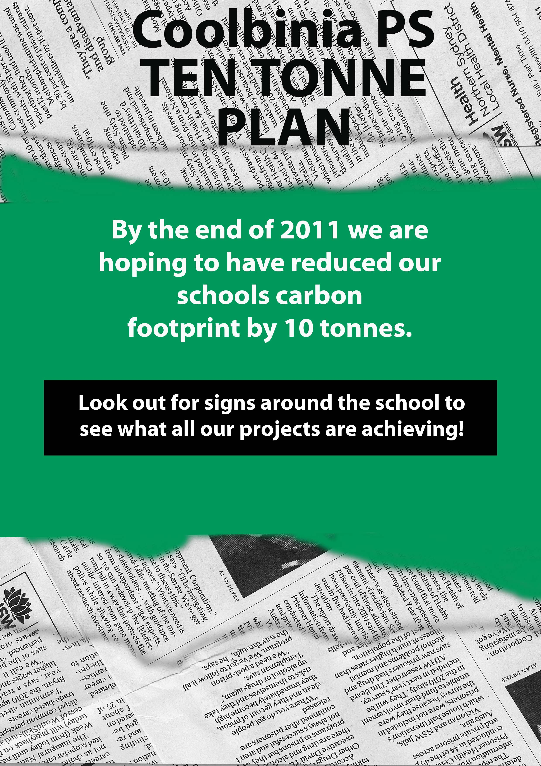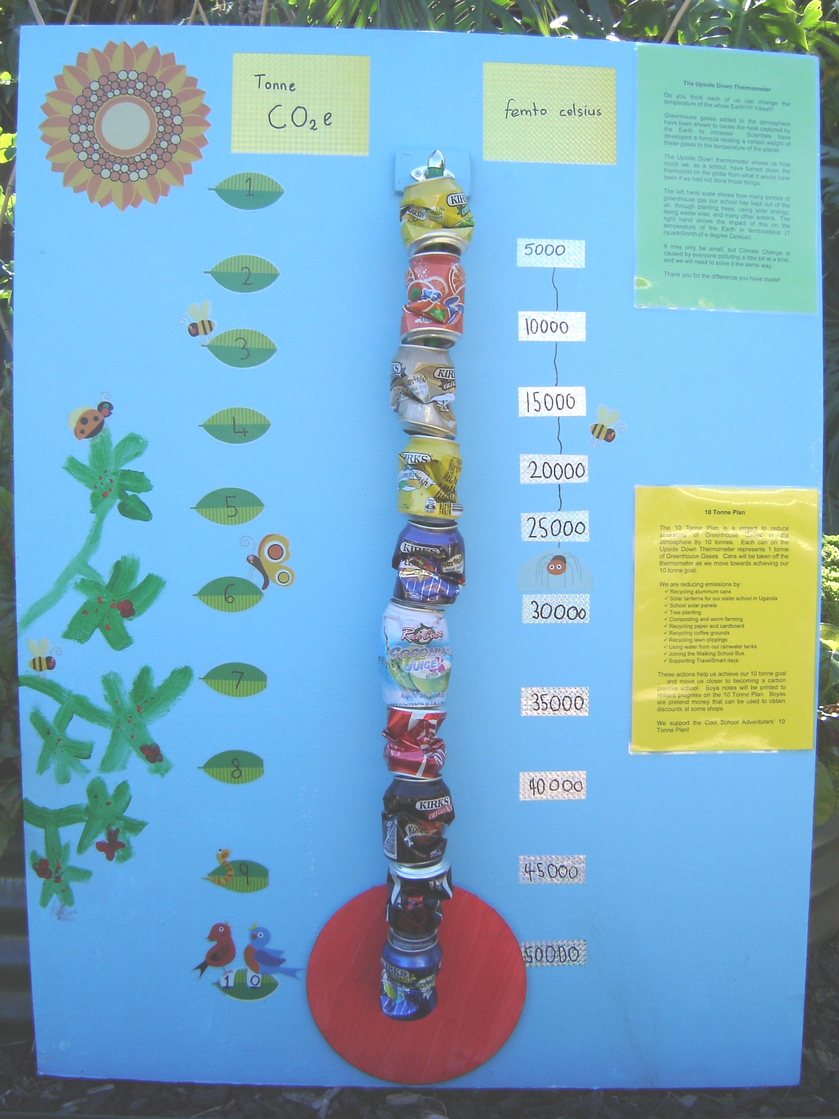
A. Context
Purpose
To showcase a whole school/whole systems approach to Education for Sustainability (EfS), linking the various components of the Australian Sustainable Schools Initiative WA (AuSSI-WA) framework in the context of an inspiring, overarching vision for the school community.
Curriculum links
General Capabilities | Critical and creative thinking  Ethical understanding  Literacy  Numeracy
Cross Curriculum Priorities | Sustainability  Aboriginal & Torres Strait Islander histories and cultures  Asia and Australia’s engagement with Asia
Learning Areas | Science  Civics and citizenship

Background
Coolbinia Primary School has a long history of environmental stewardship including extensive native seedling cultivation in school greenhouses and tree planting in the 1980s. In 2008, the school community committed to becoming a ‘carbon positive’ school. The school joined the Australian Sustainable Schools Initiative in 2009 and has been an active member since, developing policies and implementing annual sustainability action plans.
In 2011, the school adopted a ‘10 Tonne Plan’ which was a whole school community sustainability initiative that embedded a cross curriculum and whole systems thinking approach. The aim of the 10 Tonne Plan was to facilitate effective action within the school community to create a more environmentally sustainable and socially just world, with the specific goal of reducing emissions of Greenhouse Gases (GHGs) to the atmosphere by 10 tonnes.
Actions included using solar energy, tree planting, recycling, worm farming, composting and walking and/or riding to school. These actions were acknowledged by the distribution of boyas, a local currency. Boyas were traded, saved or used in particular contexts, both in the school environment (e.g. fetes/stalls) and the wider community (e.g. Hulbert Street Fiesta in Fremantle).

[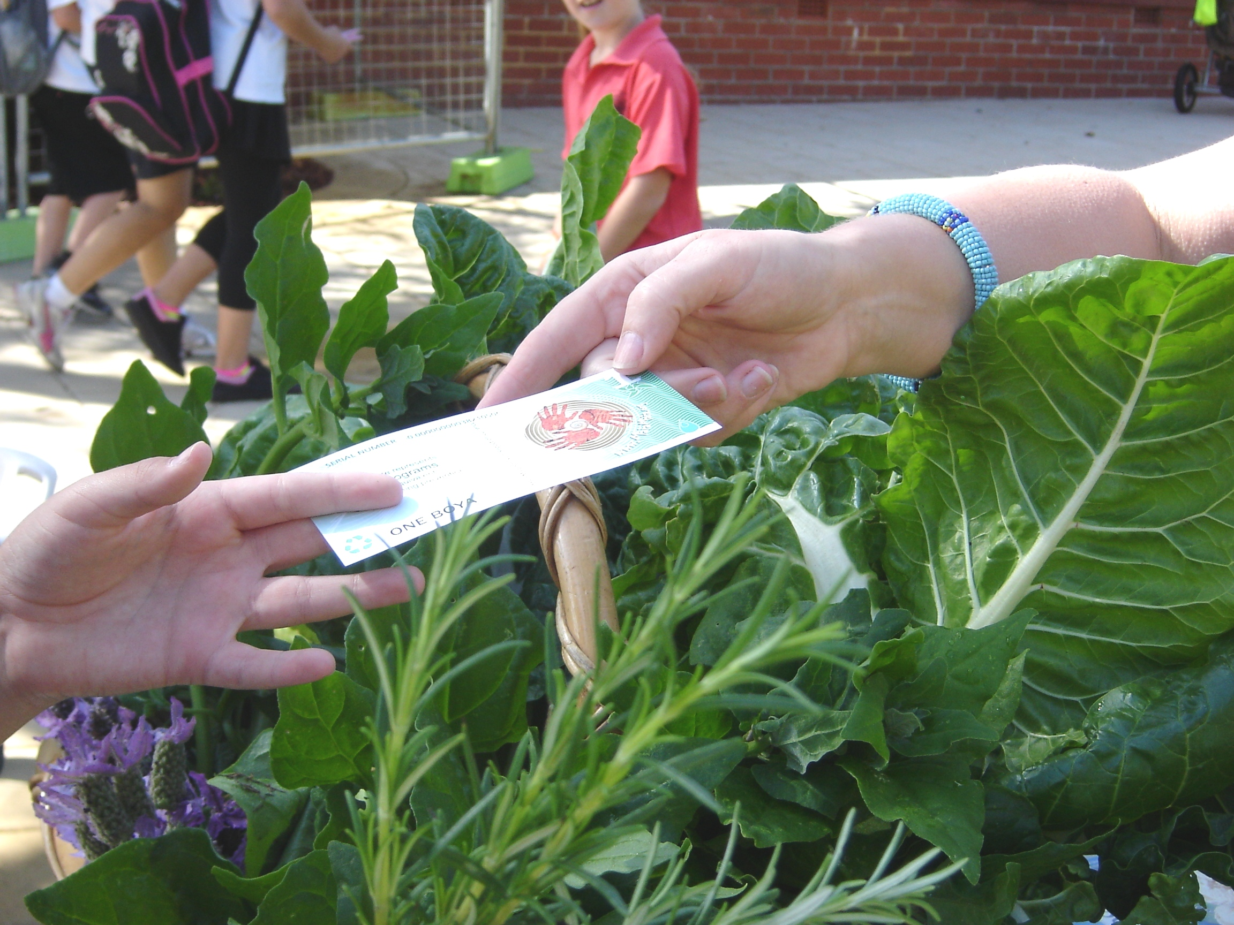
Students using Boyas

The 10 tonne goal of the 2011 plan was achieved, so the whole school community (students, staff, parents, volunteers, partners) was consulted to assess implementation strengths and weaknesses and determine the nature and size of the 2012 plan. Feedback led to the development of a ‘50 Tonne Plan’ for 2012 and implementation of this plan is underway.
Sustainability action planning
The school’s Sustainability Action Plan (SAP) is informed by utilising AuSSI-WA’s three core review, planning and evaluation tools:
- Key Elements Rubrics (KER)
- Ecological Footprint*
- Social Handprint*
* Copies of these can be found on the AuSSI-WA website in the section showcasing Sustainability Action Plans: www.det.wa.edu.au/sustainableschools.
Sustainability actions highlight significant progress in all three sections of the KER: Leadership, Teaching and Learning, and Community. Assessment on the KER was provided by all stakeholders – students, staff, parents, volunteers and partners.
Achievements in Leadership (visioning, governance and planning) are especially notable and a significant driver for progress in other elements within the Teaching and Learning and Community rubrics, all of which contribute to a successful whole school/system approach.
The main AuSSI-WA Alliance links and other connections/partnerships were as follows:
- Waste Wise Schools: http://education.dec.wa.gov.au/waste-wise.html
- Sustainable Energy Association of Australia: http://www.seaaus.com.au/
- Maia Maia Emissions Reduction Currency System: http://www.maiamaia.org/
- Solar Sister: http://www.solarsister.org/
- TravelSmart: http://www.transport.wa.gov.au/activetransport/24610.asp
- Waterwise Schools: http://www.watercorporation.com.au/
- Perth Zoo - http://www.perthzoo.wa.gov.au/
- Australian Association for Environmental Education WA: http://www.aaeewa.org.au/
Evaluation
Qualitative and quantitative methods were utilised to evaluate the 10 Tonne Plan initiative. Qualitative evidence was provided by the KERs, surveys, field notes and anecdotal feedback. Quantitative data (e.g. waste statistics) was collected to provide evidence related to the various actions (e.g. tonnes of paper/cardboard recycled; kilograms of food scraps/lawn clippings composted). In addition, a joint research project between Murdoch University and the school was undertaken in 2011-2012 to assess the outcomes of the 10 Tonne Plan. This project involved surveys and interviews of all stakeholders.

10 Tonne Plan – Gardening Outcomes Poster

B. Action
Ecological Footprint Action Learning Areas
All students were provided with opportunities to contribute to the different aspects of the 10 Tonne Plan e.g. students from K-7 participated in gardening sessions, recycled food scraps and brought in aluminium cans, mobile phones and batteries for recycling.
However, as children moved through the various year levels they had the opportunity to focus closely on particular aspects of the Ecological Footprint at different stages of their schooling to provide in-depth learning experiences.
The scope and sequence for education for sustainability links directly with the Australian Curriculum ‘Science’:
- Biodiversity: K-Yr3 (ACSSU002; ACSSU017; ACSSU211; ACSSU044, ACSHE013, ACSHE021)
- Water: Yr 2 (ACSSU032, ACSHE022)
- Purchasing and Waste: Yr 4 (ACSSU075, ACSHE062)
- Air and Transport: Yr 5 (ACSSU077, ACSHE082, ACSHE217)
- Energy: Yr 6 (ACSSU219, ACSHE099, ACSHE100, ACSHE220)

Year 3 students, for example, engaged with a Turtle Watch program (http://www.aaeewa.org.au/turtlewatchedkit.html) that addressed the biology of turtles, as well as implementing turtle conservation actions.
Year 4 classes managed activities related to recycling, composting, litter prevention and worm farming, and engaged in lessons targeting waste management knowledge with associated skills.
Year 5 students were responsible for the various aspects of being a ‘water wise' school, such as planting endemic species, watering hanging baskets using rainwater from tanks and participating in incursions/excursions conducted by the Water Corporation. It is important that sustainable practices are embedded into the content of the curriculum taught and not seen as an add-on. The above examples illustrate how this is achieved for the Science content.
The scope and sequence for education for sustainability similarly links directly with other Australian Curriculum Learning Areas and in particular Geography (draft), History, English and Civics and Citizenship (draft).
Social Handprint Action Learning Areas
Strong links were developed between the ecological footprint and social handprint. For example, the money raised from recycling aluminium cans and mobile phones was utilised, through our partnership with the Solar Sister organisation, to purchase solar lanterns to replace polluting kerosene lanterns. By this means the community demonstrated global citizenship. The following diagram shows how this worked:

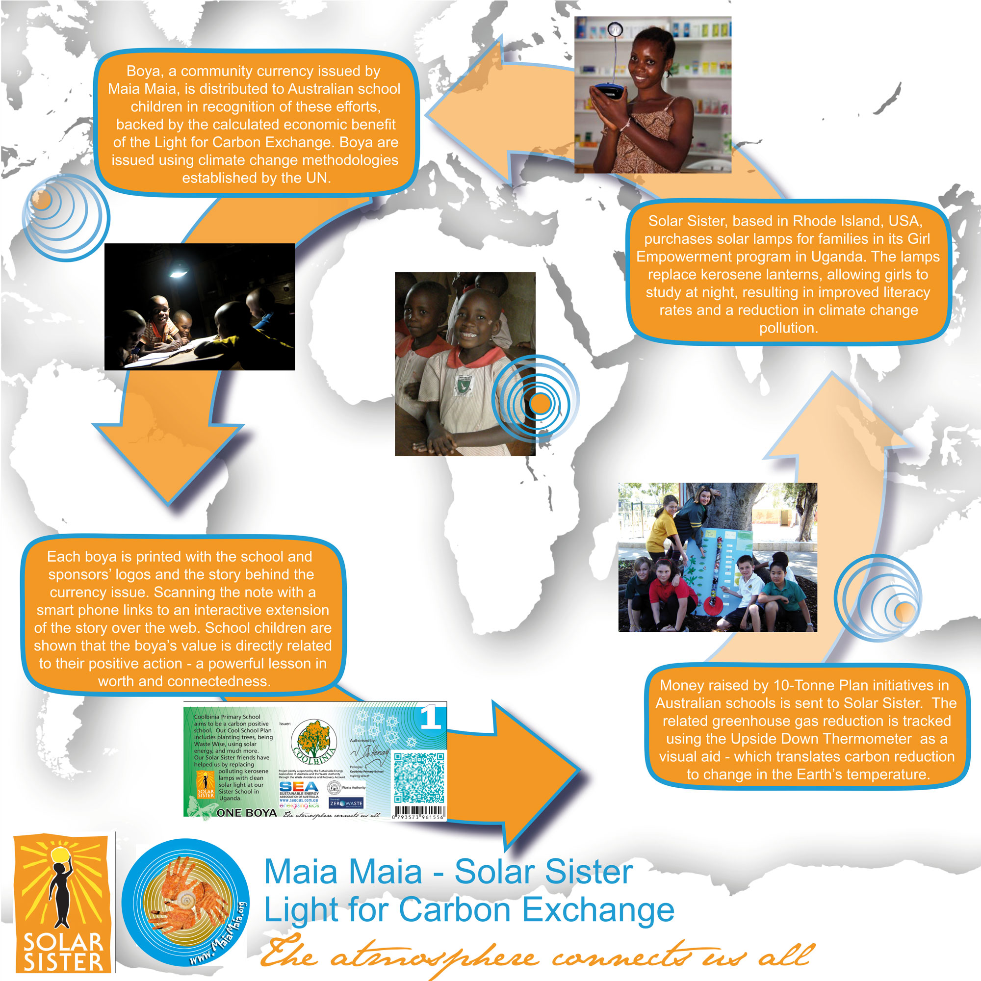
A Global Perspective

Other partnerships resulted in students planting hundreds of trees in bushland, selling indigenous wrist bands and community displays of turtle conservation posters. These and other activities connected to Coolbinia Primary’s overarching vision (10 Tonne Plan) have clear connections to all 3 cross curriculum priorities: sustainability; Aboriginal and Torres Strait Islander histories and cultures, and Asia and Australia’s engagement with Asia.
In summary, the school implemented programs within a whole systems thinking framework to ensure all students, by the time they left the school, had gained an overall understanding of sustainability. Students were provided with in-depth exposure to all ‘action learning areas’ of the ecological footprint and social handprint, and had many opportunities to demonstrate appropriate actions and behaviours.

Upside Down Thermometer: Measuring progress
Greenhouse gases (GHGs) added to the atmosphere have been shown to cause the heat captured by the Earth to increase. Scientists developed a formula relating a certain weight of these gases to the temperature of the planet. The Upside Down Thermometer shows us how much we, as a school, have turned down the thermostat on the globe from what it would have been if we had not done those things. See the following Upside Down Thermometer diagram.
The left hand scale shows how many tonnes of GHGs our school has kept out of the atmosphere through planting trees, using solar energy, being ‘waste wise’, coming to school in a ‘travelsmart’ way, raising funds to benefit the environment and people, as well as many other actions. The right hand scale shows the impact of this on the temperature of the Earth in femtocelsius (1 /quadrillionth of a degree Celsius). It may only be small, but Climate Change is caused by everyone polluting a little bit at a time, and we will need to solve it the same way.
Each can on the Upside Down Thermometer represents 1 tonne of GHGs. Cans were removed as we moved towards attaining our 10 tonne goal. Students and community members were acknowledged for their actions through distribution of boyas.
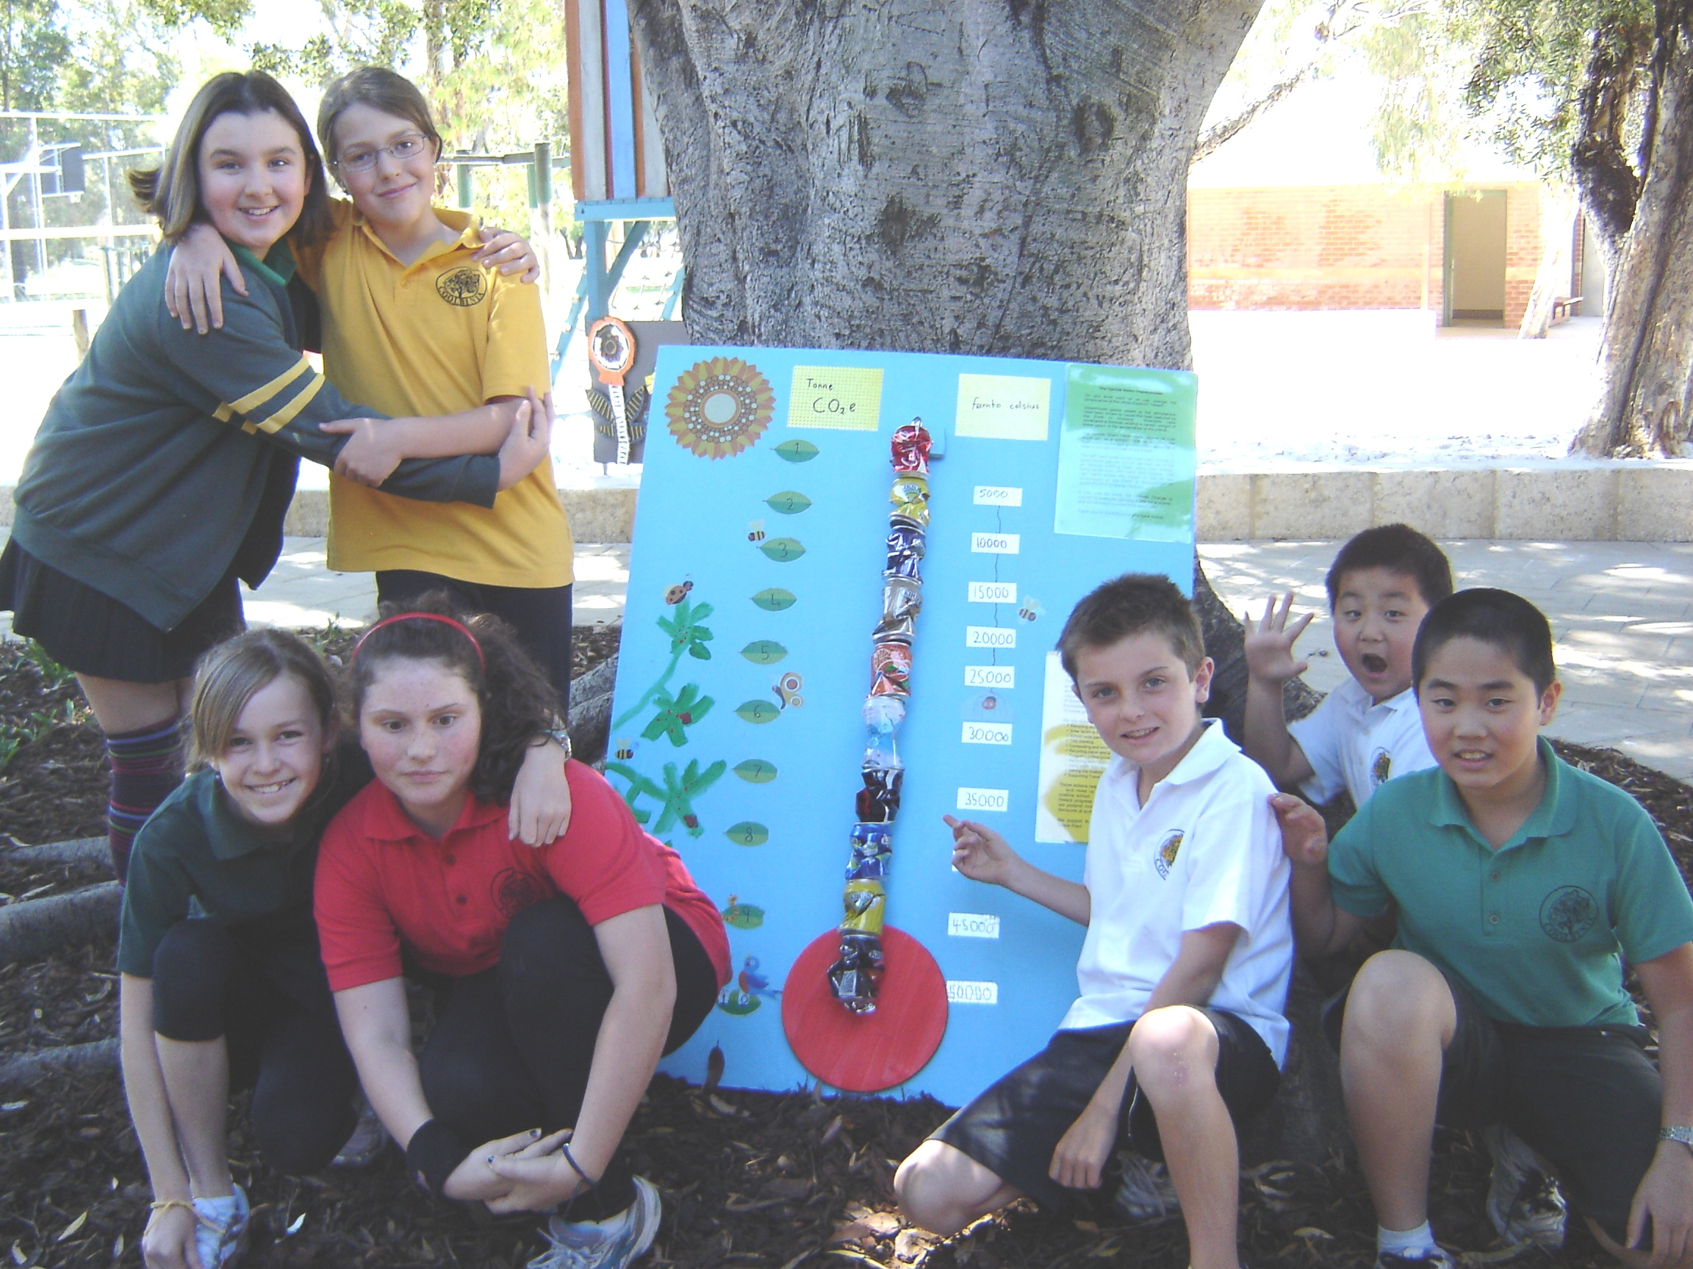
Students & their Upside Down Thermometer

Results
Key results were:
- The ‘10 Tonne Plan’ GHG goal for 2011 was achieved and confirmed by Maia Maia Emissions Reduction Currency System (environmental accountant). See: http://www.maiamaia.org/test/67-coolbinia-cool-school.html

- All stakeholders contributed to the success of the initiative which promoted whole school, whole systems thinking sustainability outcomes.
See the video clip at http://www.maiamaia.org/

- The school community supported the adoption of a new GHG goal, a ’50 Tonne Plan’ for 2012.

C. Reflection
What facilitated the process?
Leadership and community support; access to funding support (school-based, grants, in-kind); understanding of whole systems thinking (supported by relevant professional learning and engagement); ‘champions’ (including students, staff, parents, volunteers, partners).
What were the challenges?
Reinforcing the importance of critical contexts within teaching and learning to ensure that all staff contribute to the school vision as part of their everyday work; maintaining commitment with personnel changes.
Conclusion?
The ‘10 Tonne Plan’ is an effective strategy for bringing together the whole school community in a whole systems thinking approach which highlights relationships between the various components of the AuSSI-WA model specifically the ecological footprint, social handprint and key elements.
Recommendation?
If Coolbinia Primary’s 10 Tonne Plan vision resonates with you, you might want to consider how it could apply to your own school – a 10, 20, 50, even 100 tonne plan could become a reality based on your school’s context including interest, enthusiasm and resources (‘the sky’s the limit’!).

Contacts: Elaine.Lewis@education.wa.edu.au

